- Likhith Shetty
1st degree connection· 1st
M.Sc EEE LU Sweden || Master Thesis- SDU Odense|| Analog RFIC || Ex-Samsung(SSIR - R&D) || PES University - 2021
- Jul 22, 2023Gautham Shetty sent the following messages at 9:12 PM
View Gautham’s profile
Gautham Shetty 9:12 PM

Which technology you are working
- Jun 20, 2025
View Gautham’s profile
Gautham Shetty 11:04 AM

how is your course & experience in lund university
- Likhith Shetty sent the following messages at 12:03 PM
View Likhith’s profile
Likhith Shetty 12:03 PM

Hi hello Gautham !!!(Edited)

Yes it's Good 😀, just completed my first year , still working on IC project extended our team deadline 😅(Edited)
- View Likhith’s profile
Likhith Shetty 12:06 PM

Course structure is good , so there's Analog and Digital Track, I have chosen Analog track , untill now experience wise it's tough course but whatever we studied from Btech it's the continuation
- Gautham Shetty sent the following messages at 2:24 PM
View Gautham’s profile
Gautham Shetty 2:24 PM

👍
- View Gautham’s profile
Gautham Shetty 2:25 PM

it would cover radio frequency analog & analog digital mixed design
- Likhith Shetty sent the following message at 2:47 PM
View Likhith’s profile
Likhith Shetty 2:47 PM

Yes correct, ADDA mixed signal and RF courses
  - Remove reaction👍1

- Gautham Shetty sent the following message at 2:58 PM
View Gautham’s profile
Gautham Shetty 2:58 PM

hope you will perform ADVANCED USE CASES FOR MIXED-SIGNAL & RF DESIGN as part of final project or thesis
- Likhith Shetty sent the following message at 3:17 PM
View Likhith’s profile
Likhith Shetty 3:17 PM

Yes yes I have taken ICP in RF Design, so I'm continuing in PCB design i next sem in RF as well as Master thesis
- Gautham Shetty sent the following messages at 3:18 PM
View Gautham’s profile
Gautham Shetty 3:18 PM

That's great
- View Gautham’s profile
Gautham Shetty 3:24 PM

icp means Inductively Coupled Plasma)
- Likhith Shetty sent the following message at 3:27 PM
View Likhith’s profile
Likhith Shetty 3:27 PM

No it's Integrated Circuit Project, we say it as ICP1 and ICP2
- Gautham Shetty sent the following messages at 3:27 PM
View Gautham’s profile
Gautham Shetty 3:27 PM

Okay
- Oct 23, 2025
View Gautham’s profile
Gautham Shetty 10:12 AM

Just out of curiosity, I’m asking this. I hope by now you’ve gained advanced knowledge in analog RFIC design. Also please share thesis and designs you’ve worked on. I hope you’re now capable of designing end-to-end embedded systems, creating hard IP, and even developing a complete SoC for mobile. I’m also planning to learn the full mobile SoC design, hard IP, and embedded SOM design. Which MS program or university would you recommend for this?
- Likhith Shetty sent the following message at 10:42 AM
View Likhith’s profile
Likhith Shetty 10:42 AM

Yes sure , I have worked in RF Front end Antenna transceiver design, LNA,Mixer.
To develop full SOC u need knowledge of both analog and Digital , as far in Digital IC I have not completed ASIC design flow , as I continued my projects in Analog IC.
For Embedded System Design i would recommend KTH, chalmers , Upsala University ,KTH has solid program ,In Lund University they don't teach embedded system design rather they go into Analog and Asic designs and verification and less embedded stuffs
- Gautham Shetty sent the following message at 11:06 AM
View Gautham’s profile
Gautham Shetty 11:06 AM

Ok got it they Explore more into core part.may I know project related to analog RF front end (RFIC) work you have handled here. Also thesis work you are planned to undertake
- Likhith Shetty sent the following message at 11:06 AM
View Likhith’s profile
Likhith Shetty 11:06 AM

Yes Thesis i have kept bit confidential, I'll inform you on Jan 16 th
- Gautham Shetty sent the following message at 11:08 AM
View Gautham’s profile
Gautham Shetty 11:08 AM

DOC-20251022-WA0001..pdf
265 KB
Download
- Likhith Shetty sent the following message at 11:08 AM
View Likhith’s profile
Likhith Shetty 11:08 AM

IC project 1 - RF front. End - i worked in Full duplex Transceiver Design for wireless communication
ICP 2 -PCB design - SI (Self Interference)cancellation for front end receiver
- Gautham Shetty sent the following message at 11:11 AM
View Gautham’s profile
Gautham Shetty 11:11 AM

We are using above SOM for home automation controller. It lack RF capabilities. Planning to use Texas Instruments (TI) CC3100 RFIC as separate module
- Likhith Shetty sent the following messages at 11:12 AM
View Likhith’s profile
Likhith Shetty 11:12 AM

Oh Ok ok this is PCB chip

It requires on specifications like the operating frequency and Target gain and Band width we choose models
  - Remove reaction👍1

- Gautham Shetty sent the following message at 11:13 AM
View Gautham’s profile
Gautham Shetty 11:13 AM

I would like to go through project work and thesis you are undertaking if it is openly available
- Likhith Shetty sent the following messages at 11:13 AM
View Likhith’s profile
Likhith Shetty 11:13 AM

Not openly available but I will share some links
  - Remove reaction👍1

And thesis projects of past years
- View Likhith’s profile
Likhith Shetty 11:15 AM

As I'm the coauthor in my ICP. So I can't directly share my project reports without my group members permission
  - Remove reaction👍2

- View Likhith’s profile
Likhith Shetty 11:16 AM

https://en.wikipedia.org/wiki/RF_front_end

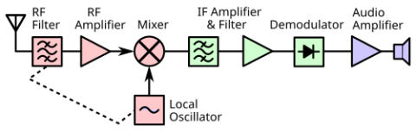

RF front end - Wikipedia
en.wikipedia.org

- Gautham Shetty sent the following message at 11:17 AM
View Gautham’s profile
Gautham Shetty 11:17 AM
Likhith: Yes sure , I have worked in RF Front end Antenna transceiver design, LNA,Mixer. To develop full SOC u need knowledge of both analog and Digital , as far in Digital IC I have not completed ASIC design flow , as I continued my projects in Analog IC. For Embedded System Design i would recommend KTH, chalmers , Upsala University ,KTH has solid program ,In Lund University they don't teach embedded system design rather they go into Analog and Asic designs and verification and less embedded stuffs…see more

May I know for RF front end design (RFIC) courses you have undertaken here. Overall course and related work you have undertaken taken here
- Likhith Shetty sent the following messages at 11:17 AM
View Likhith’s profile
Likhith Shetty 11:17 AM

https://lup.lub.lu.se/search/files/70137067/thesis_EllieCijvat.pdf

thesis_EllieCijvat.pdf
lup.lub.lu.se
LUND UNIVERSITY PO Box 117 221 00 Lund +46 46-222 00 00 CMOS Transceiver Front-Ends in Mobile Communication Handsets - Architectures and ...

These pHD report explains everything u need to know about RF front end design.
- View Likhith’s profile
Likhith Shetty 11:20 AM
Gautham: May I know for RF front end design (RFIC) courses you have undertaken here. Overall course and related work you have undertaken taken here

Yes
1)Analog Integrated Design
2) Integrated Radio Electronics
3) introduction to AD-DA convertors
4) Introduction to wireless circuits and systems
5)Modern electronics
6) Introduction to RF amplifier Design (not yet started but starting soon)

Other subjects are mix like digital and interdisciplinary background
- View Likhith’s profile
Likhith Shetty 11:22 AM

https://www.lunduniversity.lu.se/lubas/i-uoh-lu-TAEEE

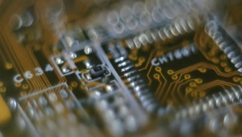

Embedded Electronics Engineering - Master's Programme
lunduniversity.lu.se

- Gautham Shetty sent the following message at 11:22 AM
View Gautham’s profile
Gautham Shetty 11:22 AM

I guess you course and overall objective looks similar to course specified here: https://youtu.be/jZIxNIzi-I8?feature=shared

Integrated Circuit Design – EE Master Specialisation

Integrated Circuit Design – EE Master Specialisation
youtube.com
- Likhith Shetty sent the following messages at 11:23 AM
View Likhith’s profile
Likhith Shetty 11:23 AM
Gautham: I guess you course and overall objective looks similar to course specified here: https://youtu.be/jZIxNIzi-I8?feature=shared

Yeah it's IC course like there's micro electronics course specialization (Integrated circuits)in IITs nd NITS in India for mtech (Edited)
- View Likhith’s profile
Likhith Shetty 11:24 AM
Gautham: I guess you course and overall objective looks similar to course specified here: https://youtu.be/jZIxNIzi-I8?feature=shared

Oh I got this offer from this university i rejected at end
- Gautham Shetty sent the following messages at 11:24 AM
View Gautham’s profile
Gautham Shetty 11:24 AM

Okay
- View Gautham’s profile
Gautham Shetty 11:34 AM

Is the embedded electronics engg course you’re studying different from embedded system design? How does your course differ from the IC design course I mentioned earlier—especially since you’ll be working on RF front-end (RFIC) design? Could you share the tools, specifications, and techniques used in your program?
(Edited)
- Likhith Shetty sent the following messages at 11:52 AM
View Likhith’s profile
Likhith Shetty 11:52 AM

Yes course name it's bit confusing - it's not embedded system it's ASIC design course I would say.
2)My course is itself IC design course, no confusion here
3)Tools - Matlab, Cadence virtuoso, VHDL coding - xlinix vivado,Layout - Virtuoso, ADS keysight,Keycad(PCB design), yes these tools mostly cover all my lab courses
So I work in RF frequency range (several Giga hetz)so I design all circuits in CMOS level.
(Edited)
- View Likhith’s profile
Likhith Shetty 11:54 AM
Likhith: https://lup.lub.lu.se/search/files/70137067/thesis_EllieCijvat.pdf

Refer this PDF 90% of time I work in these areas , it takes time to understand RF design due to its complexity
- Gautham Shetty sent the following messages at 12:06 PM
View Gautham’s profile
Gautham Shetty 12:06 PM
Likhith: Yes course name it's bit confusing - it's not embedded system it's ASIC design course I would say. 2)My course is itself IC design course, no confusion here 3)Tools - Matlab, Cadence virtuoso, VHDL coding - xlinix vivado,Layout - Virtuoso, ADS keysight,Keycad(PCB design), yes these tools mostly cover all my lab courses So I work in RF frequency range (several Giga hetz)so I design all circuits in CMOS level.…see more

Got it
- View Gautham’s profile
Gautham Shetty 2:19 PM

Do you use 5nm technology. If you have access to foundry pdk's, you can build 5nm Analog chip in virtuoso I guess. Do you follow following open source project to develop high frequency RF front end ( RFIC) design or any open source for reference and customization
- View Gautham’s profile
Gautham Shetty 2:24 PM

https://analogicus.com/rply_ex0_sky130nm/?utm_source=chatgpt.com

Analog design flow with Sky130nm
analogicus.com
Tutorial and Tools

- Likhith Shetty sent the following messages at 2:24 PM
View Likhith’s profile
Likhith Shetty 2:24 PM

1)5 nm is very advanced node only few companies have access, like samsung, TSMC,intel.
2)Here in my college we design using 65nm technology , PhD students have access to 28nm.
3)No I don't have information about open source project.I would recommend Key sight ADS , but it's paid version again to build and test RF blocks ,but majorly u need access to cadence virtuoso
(Edited)
- View Likhith’s profile
Likhith Shetty 2:26 PM

In my current project We had access to ST micro electronics CMOS 65nm pdk models and CMOS RF pdk models ,not TSMC or samsung pdk,
  - Remove reaction👍1

- Gautham Shetty sent the following messages at 2:34 PM
View Gautham’s profile
Gautham Shetty 2:34 PM

Which one you liked ADS or Cadence. Just wondering whether you could share me advanced high frequency usecases probably step by step reference

Designing using above tools
- View Gautham’s profile
Gautham Shetty 2:38 PM
Likhith: 1)5 nm is very advanced node only few companies have access, like samsung, TSMC,intel. 2)Here in my college we design using 65nm technology , PhD students have access to 28nm. 3)No I don't have information about open source project.I would recommend Key sight ADS , but it's paid version again to build and test RF blocks ,but majorly u need access to cadence virtuoso…see more

Industry currently using 5nm technology. How you guys would be able to bridge and apply 65nm knowledge
- Likhith Shetty sent the following messages at 2:49 PM
View Likhith’s profile
Likhith Shetty 2:49 PM
Gautham: Which one you liked ADS or Cadence. Just wondering whether you could share me advanced high frequency usecases probably step by step reference

I like cadence and its very advanced u can do design , layout , floorplan , everything, keysight ADS is also useful but I dont use it much in my curriculum.
as a beginner U can design Low noise amplifier design in Keysight ADS as cadence is not open source
as an example , but you need to derive it using small signal analysis model derivation for Gain,Bandwidth,cutoff freq and read
many IEEE papers(Edited)
- View Likhith’s profile
Likhith Shetty 2:50 PM
Gautham: Industry currently using 5nm technology. How you guys would be able to bridge and apply 65nm knowledge

Theres
not much difference in the simulation , fundamentals remain same even if u shrink technology to 1-2 nm,
results are almost similar theres only trendbreak with lower techology nodes is sizing of transistors(W/L) and leakage issues(Edited)
- Gautham Shetty sent the following messages at 6:24 PM
View Gautham’s profile
Gautham Shetty 6:24 PM

👍
- View Gautham’s profile
Gautham Shetty 6:26 PM

I will install any of this tool. Will work of this aspects
- Likhith: I like cadence and its very advanced u can do design , layout , floorplan , everything, keysight ADS is also useful but I dont use it much in my curriculum. as a beginner U can design Low noise amplifier design in Keysight ADS as cadence is not open source as an example , but you need to derive it using small signal analysis model derivation for Gain,Bandwidth,cutoff freq and read many IEEE papers…see more

If you come across any study material that explains the complete design flow using the above tools—from specifications to the final design ready for fabrication—particularly for high-frequency (RFIC) designs, I’d appreciate it if you could share it with me.
(Edited)
- Likhith Shetty sent the following messages at 7:01 PM
View Likhith’s profile
Likhith Shetty 7:01 PM

Ok but to understand the design , U need to learn prerequisite courses like Analog Integrated circuit - I would say refer Behzad Razavi , for RF amplifier concepts u can check out RFIC book from behzad razavi as well(Edited)
- View Likhith’s profile
Likhith Shetty 7:03 PM

But cadence manuals , I dont think its available online , as they keep it confidential and its paid version
, but you can check online like cadence tutorials in youtube , and keysight ADS youtube playlist , where they design starting from small design.(Edited)
- Gautham Shetty sent the following messages at 7:22 PM
View Gautham’s profile
Gautham Shetty 7:22 PM

Thanks
- Oct 26, 2025
View Gautham’s profile
Gautham Shetty 6:52 PM

Just out of curiosity, I have a few questions. Are you planning to pursue a PhD, and if so, what would be your research area? Also, what is the total cost of your current master’s program? I hope you can hear me clearly. When do you expect to complete this course? What are your future plans, and how much would a PhD cost?
- Likhith Shetty sent the following messages at 7:22 PM
View Likhith’s profile
Likhith Shetty 7:22 PM

Sorry I keep my plans confidential , and usually don't share openly

Masters programme in Sweden cost around 45-50 lakhs, including tution fee and living cost

I will complete my course on July 1 st week 2026

PhD in Europe is funded so they pay according to the industry standards
- Gautham Shetty sent the following messages at 9:15 PM
View Gautham’s profile
Gautham Shetty 9:15 PM

Interesting
- View Gautham’s profile
Gautham Shetty 9:51 PM
Likhith: https://lup.lub.lu.se/search/files/70137067/thesis_EllieCijvat.pdf

Doesn't cover Multi-standard 5G RF Front-End, Multi-Radio Integration (Wi-Fi, BT, GPS, 5G), System-in-Package (SiP) / FEM Integration - Packaging / Antenna Level** | RF switch, filter, antenna tuning, High-frequency RFIC (mmWave or SiGe)(Edited)
- Likhith Shetty sent the following messages at 10:20 PM
View Likhith’s profile
Likhith Shetty 10:20 PM

Yes this Phd thesis doesn't cover all the topics(Edited)

RF is very broad domain, it's subdivision and underlying of these topics and many theoritical parts is covered in another masters programme called called wireless communication (Edited)

You can research these topics in Wireless communication course list
- View Likhith’s profile
Likhith Shetty 10:23 PM

https://www.lunduniversity.lu.se/lubas/i-uoh-lu-TAWIR



Wireless Communications - Master's Programme
lunduniversity.lu.se

- Gautham Shetty sent the following message at 10:25 PM
View Gautham’s profile
Gautham Shetty 10:25 PM

👍
- Likhith Shetty sent the following message at 10:25 PM
View Likhith’s profile
Likhith Shetty 10:25 PM

👍
- Gautham Shetty sent the following message at 10:28 PM
View Gautham’s profile
Gautham Shetty 10:28 PM

Probably this could be different area High-frequency RFIC (mmWave or SiGe).
- Likhith Shetty sent the following messages at 10:30 PM
View Likhith’s profile
Likhith Shetty 10:30 PM

yes mmwave ,microwave and Anenna theory concepts we didnt cover much in the course

But its better to discuss with a wireless communication engineering student to understand if some of the topics cover there ,
  - Remove reaction👍1

- Oct 27, 2025Gautham Shetty sent the following message at 6:24 AM
View Gautham’s profile
Gautham Shetty 6:24 AM
Likhith: But its better to discuss with a wireless communication engineering student to understand if some of the topics cover there ,

I was wondering if you could connect me with MS or PhD students working in this area. Also, would you be able to share any related artifacts or dissertations, similar to what you shared earlier for the RFIC reference?
- Likhith Shetty sent the following messages at 12:15 PM
View Likhith’s profile
Likhith Shetty 12:15 PM

https://www.linkedin.com/in/hui-zhu-63537386?utm_source=share&utm_campaign=share_via&utm_content=profile&utm_medium=android_app

Hui Zhu – Lund University | LinkedIn
www.linkedin.com
4G/4.5G development engineer with three years of research and development working… · Erfarenhet: Lund University · Utbildning: KTH Royal Institute of Technology · Plats: Kalmar län · 84 kontakter på LinkedIn. Visa Hui Zhus profil på LinkedIn, ett...

Sure !!
- View Likhith’s profile
Likhith Shetty 12:17 PM

https://portal.research.lu.se/en/persons/aleksandar-birmancevic/

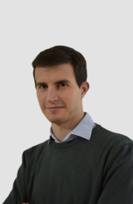

Aleksandar Birmancevic
portal.research.lu.se

- Likhith: https://portal.research.lu.se/en/persons/aleksandar-birmancevic/

He's MY TA in wireless communication subject
- View Likhith’s profile
Likhith Shetty 12:19 PM

Simple google search will give all details -wireless communication lund university phd dissertation
- Gautham Shetty sent the following messages at 2:31 PM
View Gautham’s profile
Gautham Shetty 2:31 PM

Apple A17 Pro SoC (TSMC N3E) → Apple PMIC → Qualcomm Snapdragon X70 Modem → RF Front-End Modules (Skyworks / Qorvo / Murata) → Qualcomm QTM565 mmWave AiP → Antenna Array

Is this correct flow
- Likhith Shetty sent the following messages at 2:36 PM
View Likhith’s profile
Likhith Shetty 2:36 PM

I didn't understand

Flow for what?
- Gautham Shetty sent the following message at 2:44 PM
View Gautham’s profile
Gautham Shetty 2:44 PM

《Your area》RF Front-End Modules (Skyworks / Qorvo / Murata) → 《wireless area》Qualcomm QTM565 mmWave AiP
- Likhith Shetty sent the following message at 2:53 PM
View Likhith’s profile
Likhith Shetty 2:53 PM

Yes
- Gautham Shetty sent the following message at 2:59 PM
View Gautham’s profile
Gautham Shetty 2:59 PM
Likhith: https://lup.lub.lu.se/search/files/70137067/thesis_EllieCijvat.pdf

3. Where It Fits in the Modern 5G Architecture
System Block Process / Vendor Frequency Thesis Coverage?
Apple A17 Pro SoC (TSMC N3E) Digital CMOS Baseband / IF ❌ Not covered
Qualcomm X70 Transceiver RFIC CMOS / BiCMOS 0.6 – 6 GHz ✅ Covered (theory directly applies)
Skyworks FEM (SKY58281) GaAs pHEMT + SOI 0.6 – 6 GHz ⚠️ Partially (driver-PA interface only)
Qualcomm QTM565 mmWave AiP SiGe BiCMOS + antenna array 24 – 40 GHz ❌ Not covered (beyond thesis scope)
- Likhith Shetty sent the following messages at 2:59 PM
View Likhith’s profile
Likhith Shetty 2:59 PM

I have no idea

I know only trasceiver block, where we build using hybrid coupler , Transmission line models
- Gautham Shetty sent the following messages at 3:02 PM
View Gautham’s profile
Gautham Shetty 3:02 PM

Beyond the Thesis (Evolution)
Era Frequency Technology Example New Challenge
2005–2010 0.9–2.1 GHz CMOS 3G transceiver RFIC Integration, power
2015 up to 3.5 GHz CMOS/SOI LTE-A modem MIMO, CA
2020+ 0.6–6 GHz + 24–40 GHz CMOS + GaAs + SiGe 5G sub-6 + mmWave Beamforming, packaging
2024+ 40–90 GHz SiGe, InP 6G / radar
- View Gautham’s profile
Gautham Shetty 3:06 PM
Likhith: I know only trasceiver block, where we build using hybrid coupler , Transmission line models

Transceiver was separated in older systems
If you look at older devices (e.g., Snapdragon 855 generation):
SoC (Modem) → QET5100 Transceiver → Skyworks FEM → Antenna
- View Gautham’s profile
Gautham Shetty 3:07 PM

Updated flow: Apple A17 Pro SoC (TSMC N3E)
│
▼
Apple PMIC (power rails, bias)
│
▼
Qualcomm Snapdragon X70 Modem-RF System
├─► Digital Baseband (DSP/PHY)
└─► **CMOS RF Transceiver IC** ← thesis domain
│
▼
Skyworks / Qorvo / Murata FEMs (sub-6 GHz)
│
▼
Qualcomm QTM565 mmWave AiP (phased-array RFIC + antennas)
│
▼
Antenna Array
- Likhith Shetty sent the following message at 3:10 PM
View Likhith’s profile
Likhith Shetty 3:10 PM

I actually have exam on wednesday
Ill text you this weekend
- Gautham Shetty sent the following messages at 3:11 PM
View Gautham’s profile
Gautham Shetty 3:11 PM

Snapdragon/ Skyworks / Qorvo / Murata could be the top organization working on your field curios to know about others startup working in your field
- View Gautham’s profile
Gautham Shetty 3:12 PM
Likhith: I actually have exam on wednesday Ill text you this weekend

Sorry, oh do you have regular exams? I believe you will not have Theory exams like we have in india
- Likhith Shetty sent the following messages at 3:15 PM
View Likhith’s profile
Likhith Shetty 3:15 PM

I mean we have exam for all subjects , almost all expect few project related courses
- Gautham: Snapdragon/ Skyworks / Qorvo / Murata could be the top organization working on your field curios to know about others startup working in your field

Ill discuss in detail on saturday or sunday
- Dec 21, 2025Gautham Shetty sent the following messages at 10:29 PM
View Gautham’s profile
Gautham Shetty 10:29 PM

https://www.linkedin.com/posts/rohithbhat_udupi-siliconbeachofindia-activity-7408187387790491648-SaE7?utm_source=share&utm_medium=member_android&rcm=ACoAAAOLaUcBfyPacMFnAMSn5UMKCWeCStIScik



Rohith BhatRohith Bhat • 1stVerified • 1stFounder wrkwrk/99Games/Robosoft, Founding President, TiE MangaluruFounder wrkwrk/99Games/Robosoft, Founding President, TiE Mangaluru3mo • 3 months ago • Visible to anyone on or off LinkedIn

Sophrosyne Technologies, an Indian semiconductor startup today expanded their R&D centre in hashtag#Udupi. They had raised $2 million in seed funding from Bluehill.VC last month to develop low-power biosensing chips for wearables, alongside a $1.2M MeitY grant, moving them from prototype to production. With this expansion, 60% of their workforce will be in Udupi and they are hiring for exciting roles at https://lnkd.in/gaQzS3Gt hashtag#SiliconBeachofIndia
…more
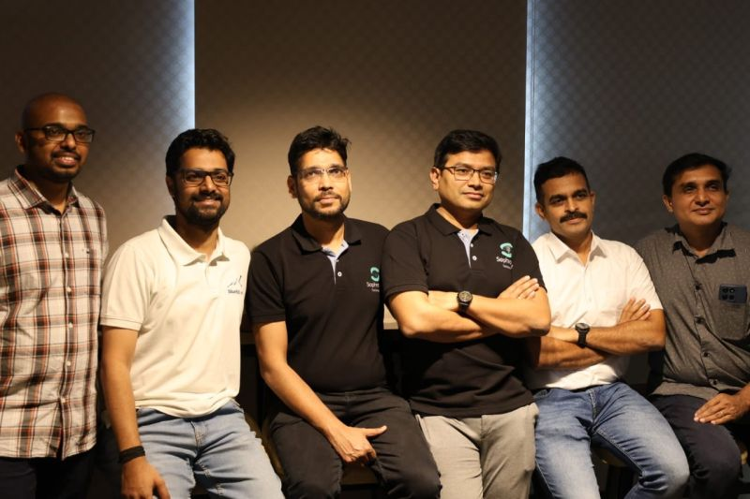
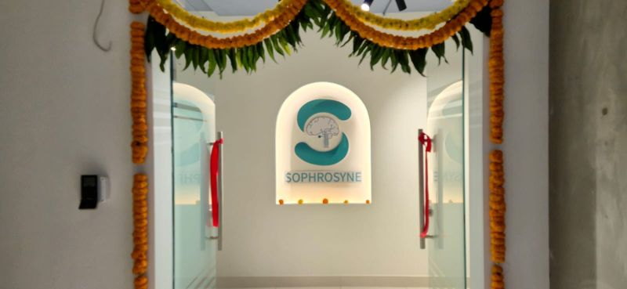
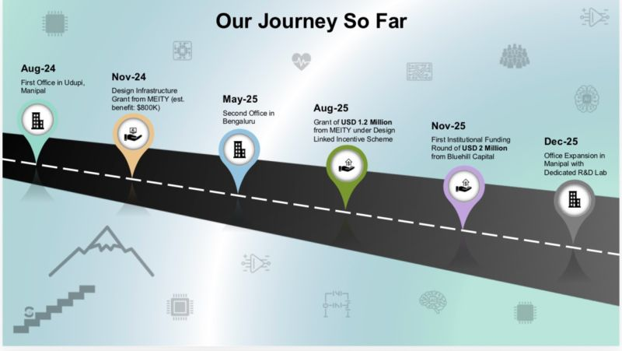
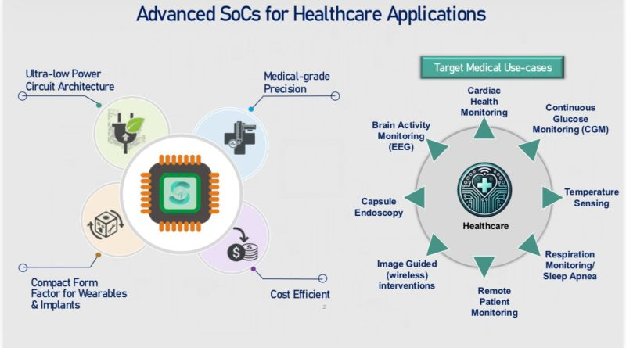
Activate to view larger image,
  - React with👍1

- View Gautham’s profile
Gautham Shetty 10:51 PM

https://www.linkedin.com/in/monikalilani?utm_source=share&utm_campaign=share_via&utm_content=profile&utm_medium=android_app

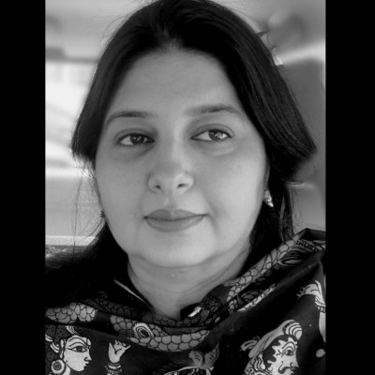

Monika Kodnani Lilani - India | Professional Profile | LinkedIn
www.linkedin.com

  - React with👍1

